

Problem Statement :

Customer retention is a measure of how many of your customers are loyal to your brand and return to make further purchases. Customer retention only deals with existing customers, with no consideration for new customers. All companies spend a lot of money acquiring customers, so it can be shocking how easily we let them walk away. It costs an estimated seven times more to acquire a new customer than it does to sell to an old one, due to factors such as lack of brand recognition, offering new customers discounts and offers and not having contact details to initiate a conversation
Customer retention can be achieved with good customer service and products. Customer retention and customer satisfaction are essential for a business to succeed. Customer satisfaction is improved by repeating businesses, brand loyalty, and positive word of mouth. Consumers prefer to stay with their current providers due to quality and price. Therefore, new anti-churn strategies must be constantly developed, but the most important for a company to prevent attrition of customers is to truly know them. The vast volumes of data collected about customers can be used to build churn prediction models. Knowing who is most likely to defect means that a company can prioritize focused marketing efforts on that subset of their customer base. Churn prediction means detecting which customers are likely to leave a service or to cancel a subscription to a service. Preventing customer churn is critically important to the telecommunications sector, as the barriers to entry for switching services are so low. Churn is obviously something you want to avoid, as it's nigh on impossible for a business to grow with a high churn rate. This makes churn a fantastic indicator of whether something is wrong with your product or service. Machine learning algorithms improve the dataset iteratively to find hidden patterns. Several studies show that machine learning can predict churn and severe problems in competitive service sectors. Predicting churning customers early on can be a valuable revenue source. Thus, a customer's churn status change explains the relationship between churn determinants and the probability of churn.

For prediction purpose, I will employ the mostly preferred tool and programming languages which Python. Python is most popular language and contains tool for machine learning and data science application due to its wide community and easy to adapt syntax.

Tools and Libraries:









For prediction of customer churn, there is requirement of customer’s data which have stopped to use service and which are existing customers in Telecommunication industry. The data have provided in csv file which have to be imported to notebook for analysis with help of libraries.

A] Import Libraries:

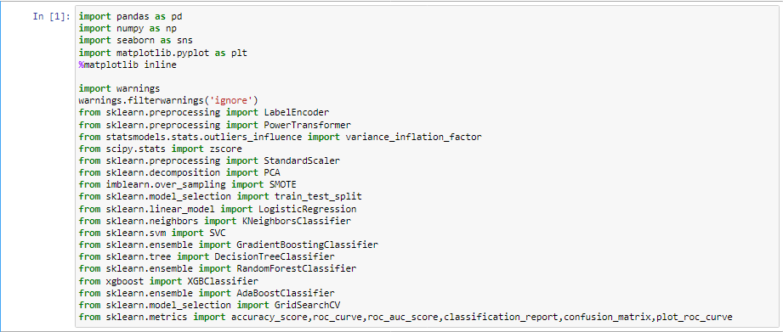

B] Importing dataset :

The data for machine learning is mostly provided in csv file or excel file from which it has to be imported into dataframe for further analysis. I have data in csv format which will be imported through given code.
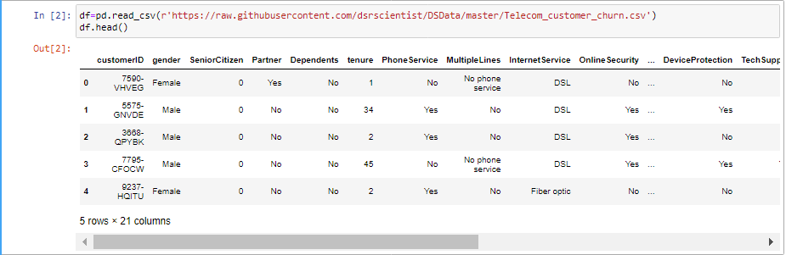
After importing dataset as named as df , it can be concluded that dataset contains 21 variables, among which some variables are categorical in nature and some are continuous ..
Let’s move forward for further analysis :
I will check for shape of dataset and data type of all variables with codes given below, it is essential to know shape and data type to make strategy about preprocessing and analysis.
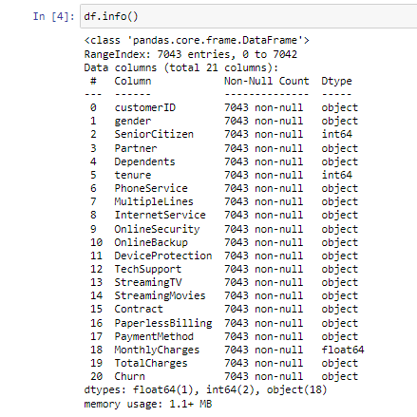

Observation: Given dataset comprises of 3 numeric and rest of variables are with object data type.

Analysis of missing records:
Missing data can skew anything for data scientists. A data scientist doesn’t want to produce biased estimates that lead to invalid results. The concept of missing data is implied in the name: its data that is not captured for a variable for the observation in question. Missing data reduces the statistical power of the analysis, which can distort the validity of the results.

Duplicate records analysis :
When an entry appears more than once, it receives a disproportionate weight during training. Duplicate entries can ruin the split between train, validation and test sets in cases where identical entries are not all in the same set. This can lead to biased performance estimates.
.

Observations :

1] The given dataframe contains 7043 rows and 21 variables .The shape of dataframe tells about what strategies can implement in further analysis
2] There are no missing records and no duplicate values are present .
1] CustomerID can be eliminating as doesn’t have any prediction power as it is Index like value.
2] ToatalCharges contains total price of service which should be continuous in nature also It has values in float form but data type of variable is Object which is string or word.
3] The all variables are non-null as observed in info.

C] Exploratory data analysis :

It is not possible know about data by just head or tail method , Hence to explore complete analysis of variables are continuous or categorical It is required to analyze the unique values and their counts and also Number of unique counts as There is some numeric data which are categorical in nature like SeniorCitizen, while some continuous data in dataset which has object data type like TotalCharges

Let’s analyze with given code for number unique values in every variables and values counts.

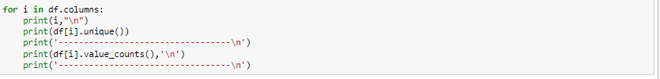

Observations :

1] TotalCharges has one category observed having no value . It is category with empty string value which missing data, which have to be imputed or eliminated from dataset depending upon relation and percentage.

4] SeniorCitizen is categorical in nature with two unique categories 0 and 1.

Elimination :
Removing records with empty string :

It is required to eliminate customrID :

Conversion of data type of TotalCharges:

- For further analysis I have split data variables into categories of continuous and categorical data with cont list for continuous and cat list for categorical.
- Categorical variables analysis with visualization with countplots in seaborn and matplotlib techniques :

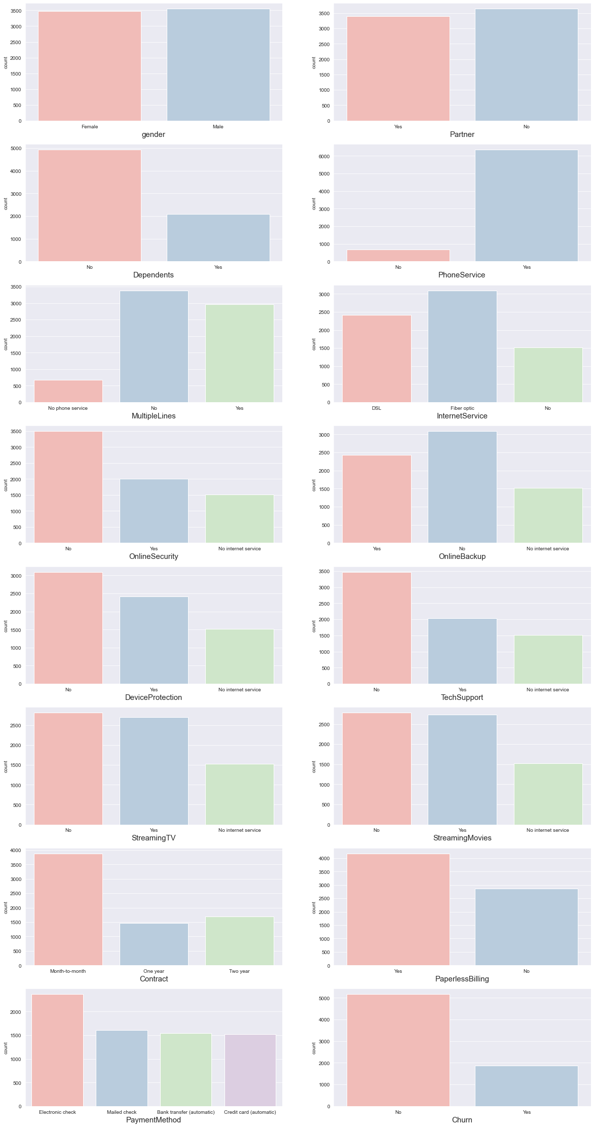

Observations:
1] Gender feature with male and female categories.
2] The Partner feature is customer with service partners with yes and No
3] The customers with No dependents have high count 5000 while 2000 customer belongs to Yes.
4] Customers with Yes phone service is High count above 6000 and cutomers with No phone service have count of less than 1000.
5] MultipleLines is service for customer with having No phone service, No and Yes.
6] InternetService feature have categorized customers as No, DSL and Fibre Optic.
7] OnlineSecurity is categorized as No internet service, Yes and No
8] OnlineBackup is categorized as No internet service, Yes and No
9] DeviceProtection is categorized as No internet service, Yes and No
10] TechSupport is categorized as No internet service, Yes and No.
11] StreamingMovies, StreamingTV have same categories .No internet service, No and Yes.
12] Contract has month to month contract, one year contract, and two year contract
13] Customer using paperless billing facilities user are more than that of paper billing facilities.
14] Payment method is categorized as electronic mail with highest count and other categories are bank transfer credit card transfer and Mailed check have approximately same count.
15] The Churn feature is label having two categories of weather customer had quit the service ( Yes ) or Continue to utilizing service of company (No). The customers have quit service are less. up to 30 %. This variance in count of No and YEs category suggest that the Imbalanced in dataset.

- After analyzing categories and their contribution in variables, Lets analyzing the customer churned rate with each categories in categorical variable s which can suggest determinants about which group of customers are more likely churned and which service utilizers have churned, This can be achieved with countplot with Churn the label variable as hue parameter which will further split each category into according Yes and No category of Churn.

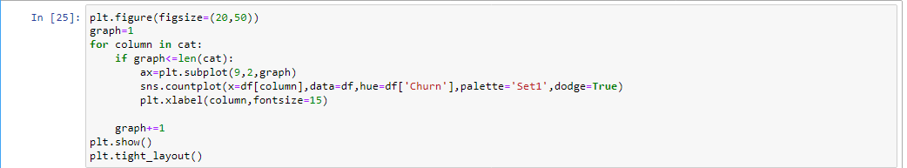
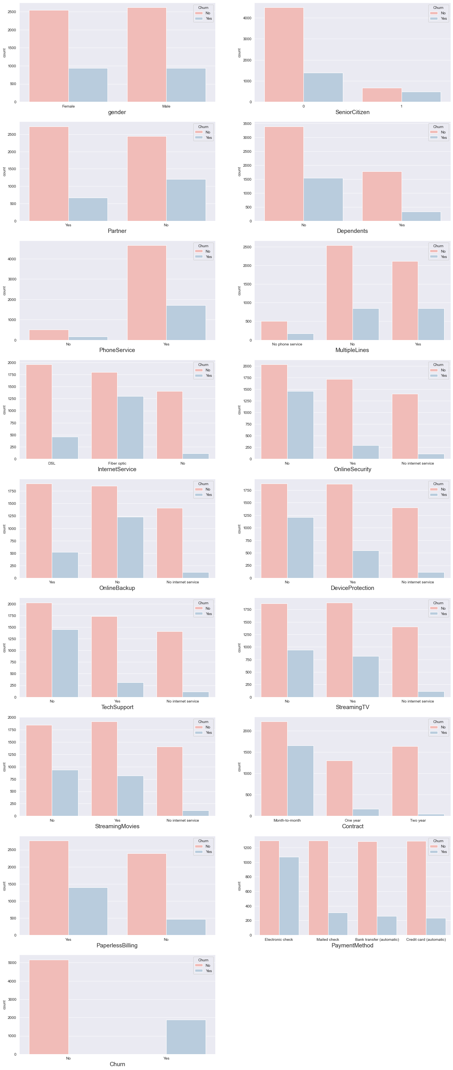

Observations:
1] The churned rate in Gender feature with Male and Female category is same with respect total count of each category.
2] SeniorCitizen:
a) The customers who have quit the service have higher proportion in total count of SeniorCitizen with value 1 category.
b) The customer quitting service has lower ratio in younger people.
3] The less churned rate is observed in customers having partner than that of No partner.
4] Approximately equal churned rate observe in Dependent category as Yes and No.
5] The higher churned rate observed in multiple lines user as compared other categories.
6] The churned rate is Up to 45% in Fibre optics internet service.
7] The churned rate is higher in internet service users without online security service.
8] The higher churned rate is observed in users without online backup facility.
9] The higher churned rate is observed in internet service users without device protection facility.
10] The higher churned rate is observed in internet service users without Technical support facility.
11] the churned rate is very high in case of customers using month to month contract. Churned rate is decreases as contract duration increases.
12] The churned rate of customers who used to pay with electronic check is higher as compared to other modes of payment.

- continuous variables analysis with distplot :
The Seaborn module along with the Matplotlib module is used to depict the distplot with different variations in it. The Distplot depicts the data by a histogram and a line in combination to it.
In given data set we have only three variables Tenure, MonthlyCharges and TotalCharges which are continuous in nature and save as list in cont. below is Distribution of continuous variables in dataset.

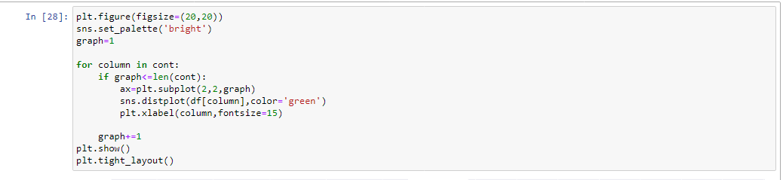
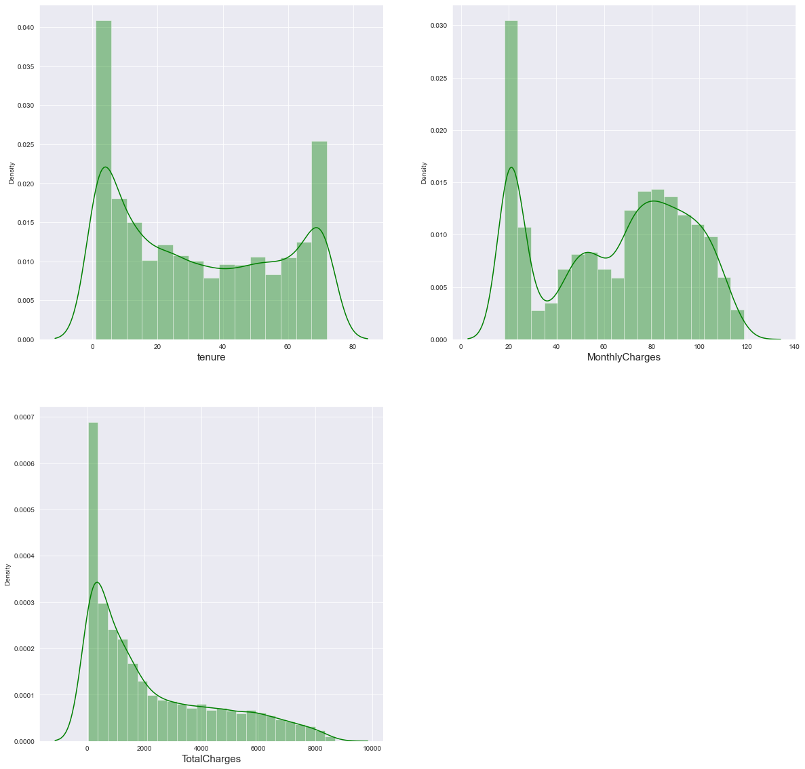
Observations:
1] TotalCharges is positively skewed .TotalCharges with zero value have high peak in distribution. It is required to continuous features to have normal distribution for better working of algorithms.

- Continuous variables analysis with Violinplot: Violin plots are used to visualize data distributions, displaying the range, median, and distribution of the data. Violin plots show the same summary statistics as box plots, but they also include Kernel Density Estimations that represent the shape/distribution of the data.
- I will visualize the distribution continuous variables with categories in variables like PaymentMethod, PaperlessBIlling and Churn.

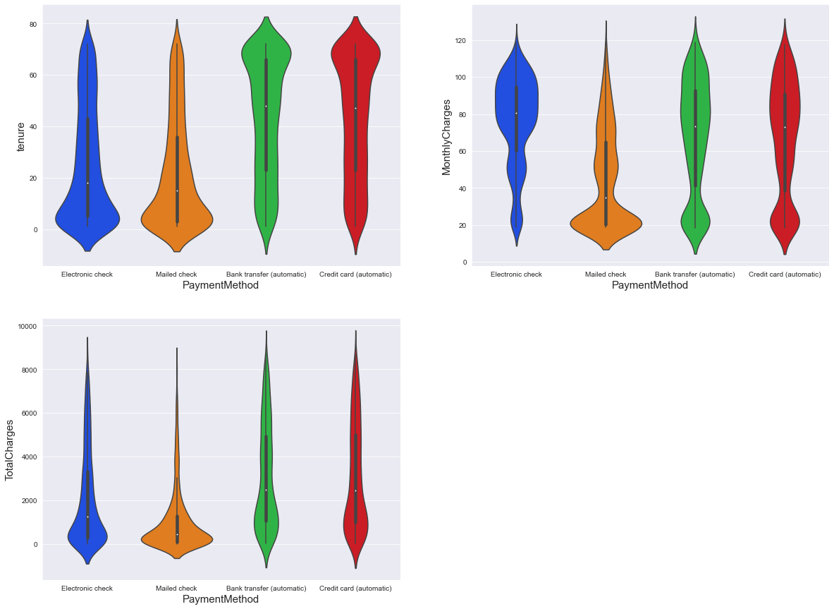
Observations:
1] The distributions of tenure, MonthlyCharges and TotalCharges features are different for different
Modes of payment in PaymentMethod.

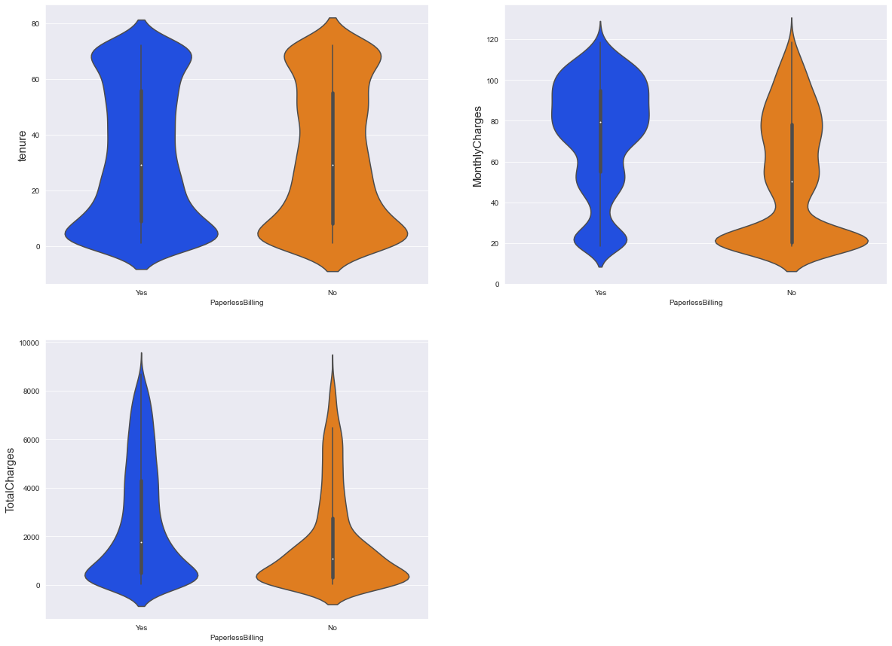

Observations:
1] The distributions of MonthlyCharges feature is different for different for PapelessBilling and Paper billing.

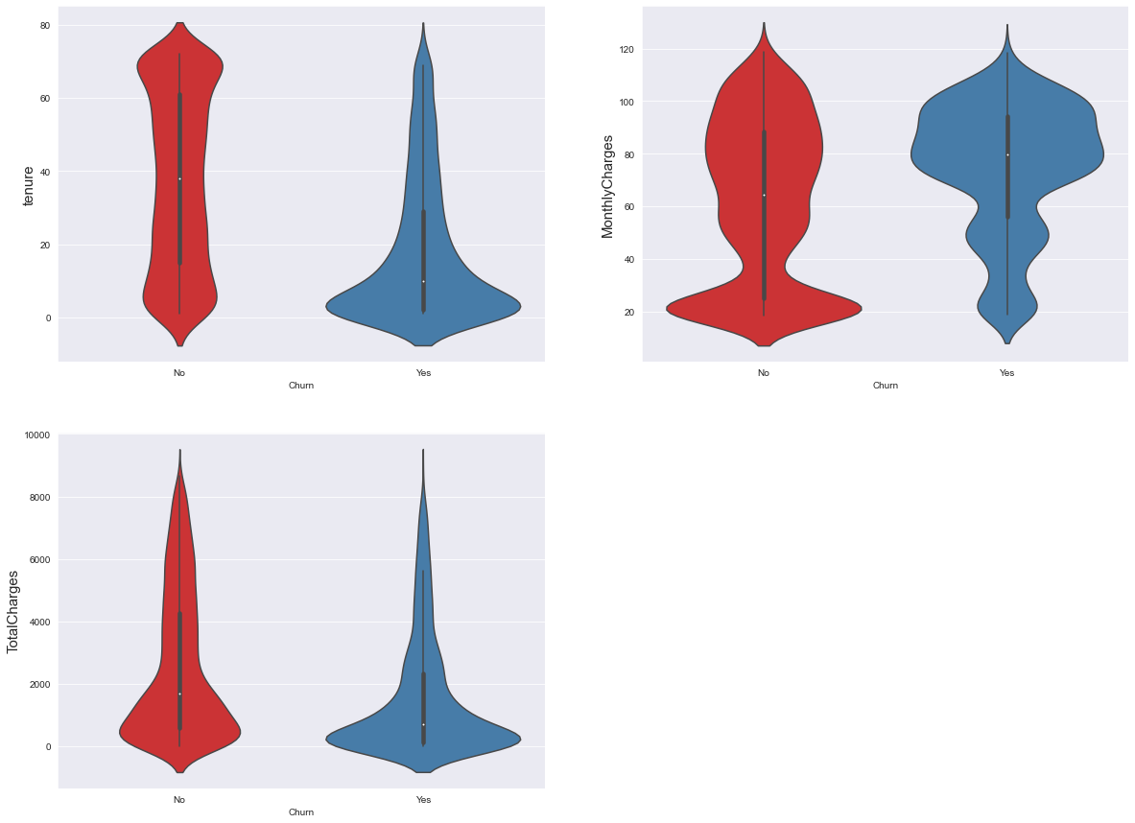
Observations:
1] Distribution of tenure customers which have quit the service is highly positive skewed.
21] Distribution of MonthlyCharges of customers which have quit the service is highly negative skewed.

D] Data Preprocessing

- Outliers Detection :
Outliers are unusual values in your dataset, and they can distort statistical analyses and violate their assumptions. Removing outliers is legitimate only for specific reasons. The box shows the quartiles of the dataset while the whiskers extend to show the rest of the distribution, except for points that are determined to be “outliers.
I will detect outliers in dataset in continuous variables with Boxplot. After detecting outliers there is crucial step that is treatment of outliers for better performance to be obtained.

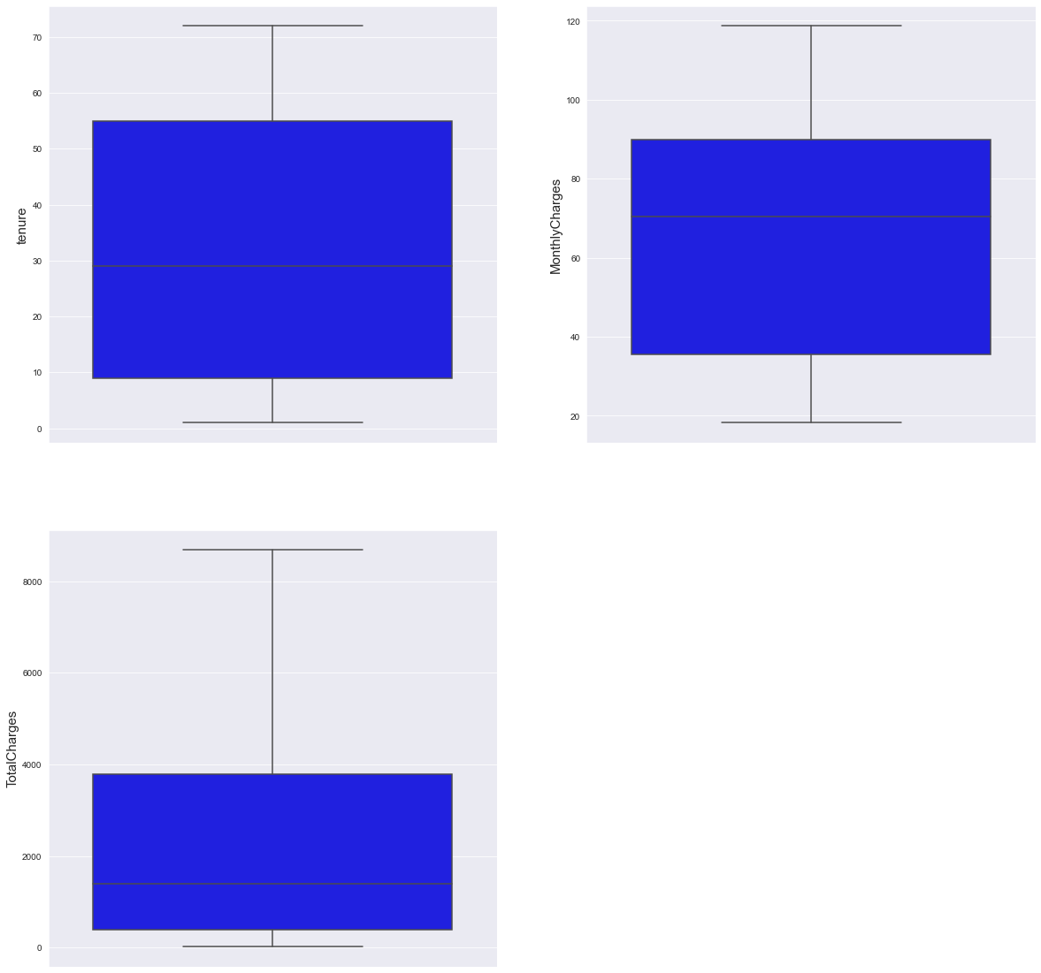
Observations: There are no outliers are present continuous features.
- Encoding
Encoding is a technique of converting categorical variables into numerical values so that it could be easily fitted to a machine learning model. LableEncoder is transformer in sklearn library which accepts data and convert it into integer values between 0 and (n_classes-1).

I have grouped all variables with object data type in obj list which will feed to LabelEncoder which will convert categories from object/string to numeric values.

The data variables after Encoding have replaced with original variables which can be observed in dataframe.
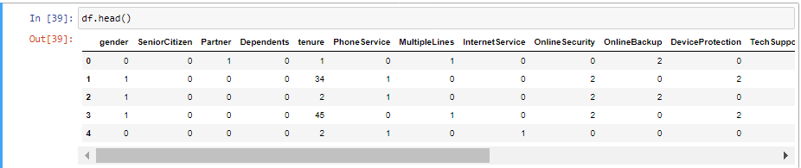
- Correlation Analysis
Correlation is an indication about the changes between two variables. We can plot correlation matrix to show which variable is having a high or low correlation in respect to another variable. This correlation matrix can be visualize with heatmap in Seaborn.

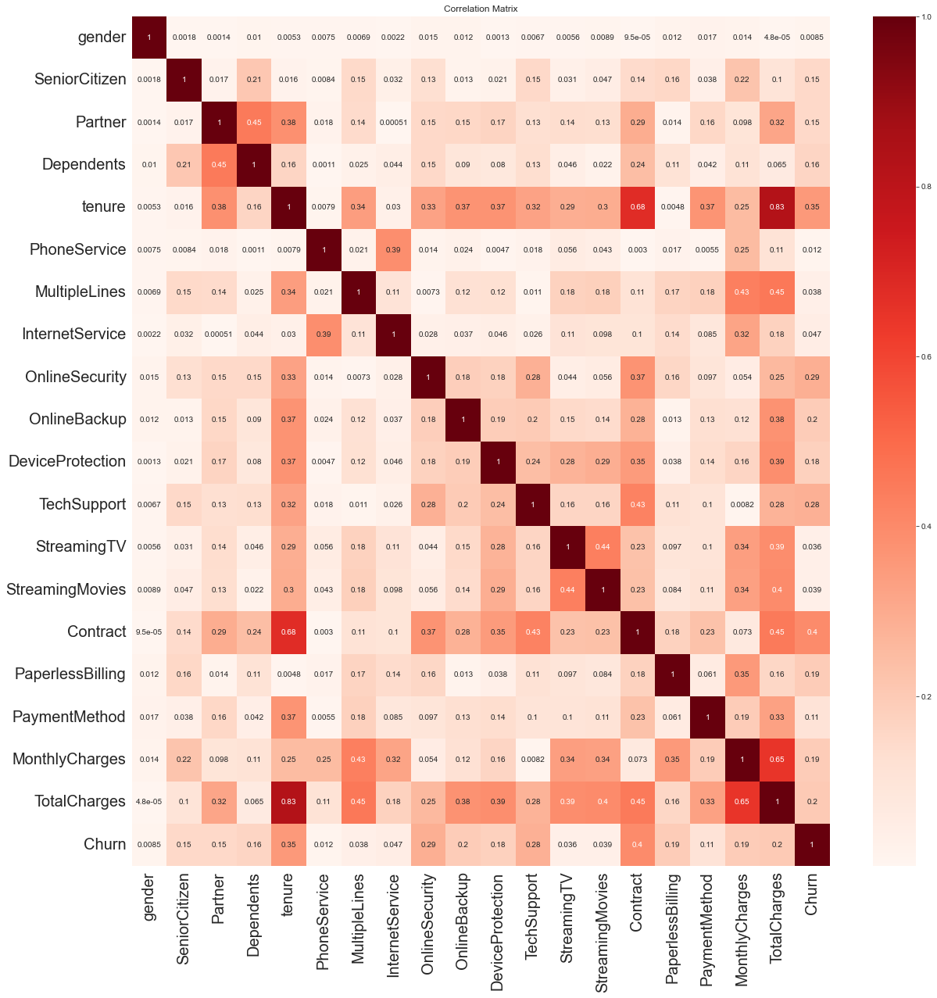

Observations:

1] There is Correlation of 0.83 between tenure and TotalCharges
2] There is Correlation of 0.68 between contract and tenure
3] There is Correlation of 0.65 between Monthly charges and TotalCharges
4] The features like Gender and phone Service have very low correlation 0.008 and 0.01 with
Label Churn.
5] Tenure and Contract these two features have higher correlation with label 0.35 and 0.39 which is also low correlation
6] These two features also have correlation between them and also exhibit positive relationship
7] MultipleLines, InternetService, StreamingTV, StreamingMovies have very less correlation with label Churn.

- Multicollinearity analysis with VIF
The multicollineaity is violation of assumptions of algorithms that predictors are independent of each other. The situation where the independent variable s are not truly independent, they some relation among them .The best way of addressing multicollinearity is with variance inflation factor.

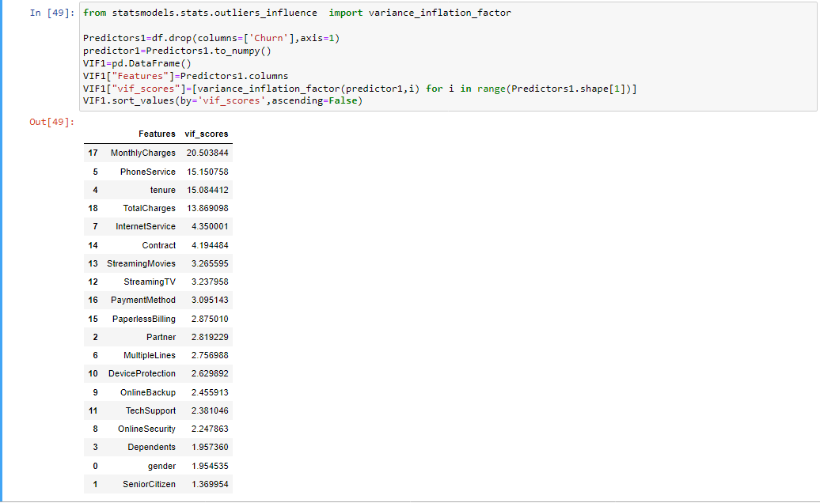

Observations:
1] From above dataset, vif values of tenure, MonthlyCharges, PhoneService and TotalCharges are above 10. These features have to be eliminating from dataset to increase interpretability.
2] But removing the features form dataset can lose important or crucial information hence, I will move towards dimensionality reduction in later part.

- Skewness and Transformation

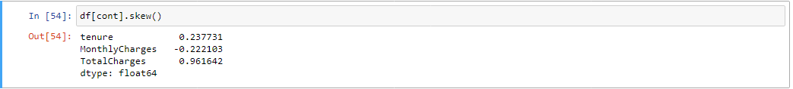

Observations:

1] The tenure and MonthlyCharges features can be considered as but TotalCharges feature is highly skewed in nature. Which have to treat before feeding to machine learning algorithms.

- Power transformation :
1] Upon analysis with Log transformation, square root transformation, I have reach to apply power transformation with yeo Johnson method to treat skewness in continuous variables.
2] The purpose of transformation is to increase the symmetry of the distribution of the features. If a feature is asymmetric, applying transformation will make it more symmetric.
3] Powertansformers are applied to data where more normality is desired. Machine learning algorithms work better when distribution is normal. For linear model it is highly crucial step.

- Analyzing skewness and normality of data after transformation

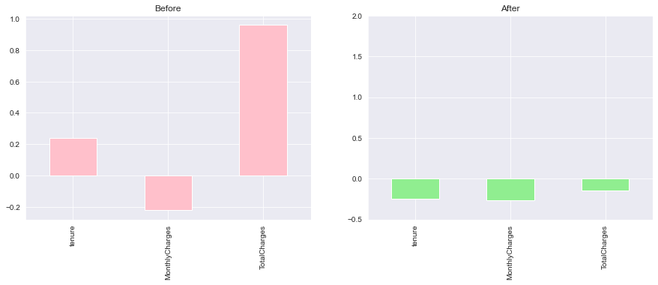
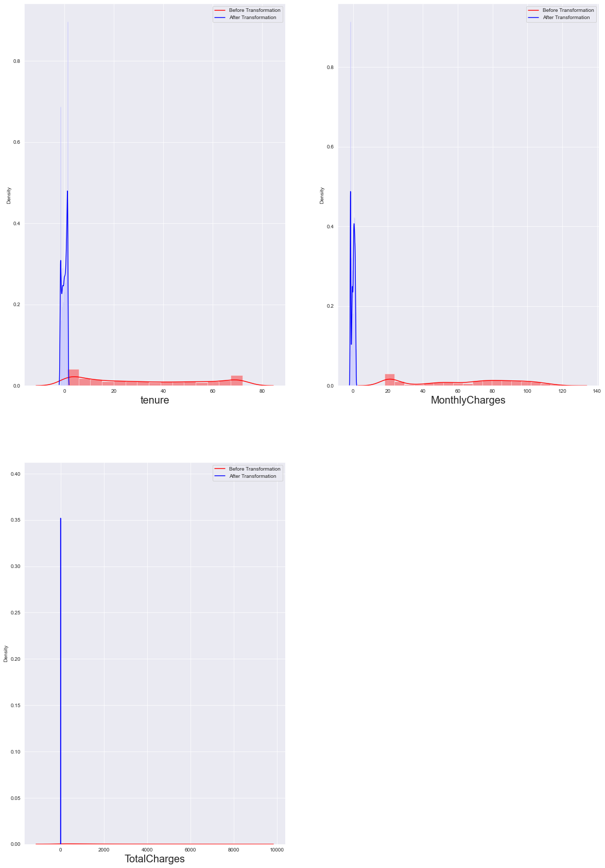
Observation: In above graphs we can analyze distribution of continuous features has been treated successfully.
- Standardization
It is required to scale all feature in same scale for better performance. StatndardScaler calculates distance of data values from mean and divide it by standard deviation for each feature independently.

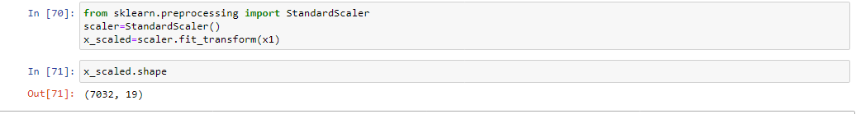

- Principal Component Analysis :

1] Principal Component Analysis is an unsupervised learning algorithm that is used for the dimensionality reduction in machine learning.
2] It is a statistical process that converts the observations of correlated features into a set of linearly uncorrelated features with the help of orthogonal transformation. These new transformed features are called the Principal Components.

In above scenario of data correlation, There is low correlation between features and label and high correlation between features as observed in VIF. Hence I will apply PCA to get uncorrelated features.

The Variance explained by each component can be analyzed with given diagram:

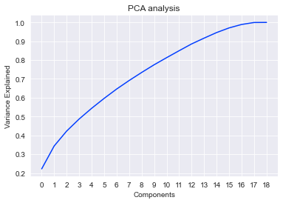
- The choosing data with 14 components of PCA which explains 91.64 % variance for model building, among Total 18 components. Because above 14 components every component is contributing very less variance in data which will not be considered.
- Imbalanced data :

The Churn is label in given machine learning task having imbalanced in categories which causes to algorithms to learn more about majority class which is NO Churn . hence the model will not be effective in predicting minority class which is Yes Churn .It is required to treat Imbalanced in data.

- SMOTE :
1] SMOTE synthesizes new minority instances between existing minority instances. These synthetic training instances are generated by randomly selecting desired number of the k_neighbors for each example in the minority class.

The minority class will imputed with synthetic data with 0.85 percentages that of majority class can be observed

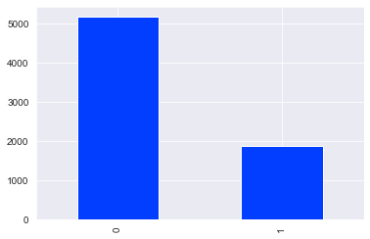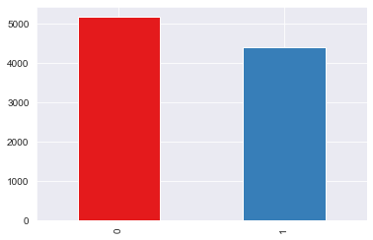

Before SMOTE After SMOTE

- Now we will find random state for which model will performance is best and random state ensures that the splits that you generate are reproducible.

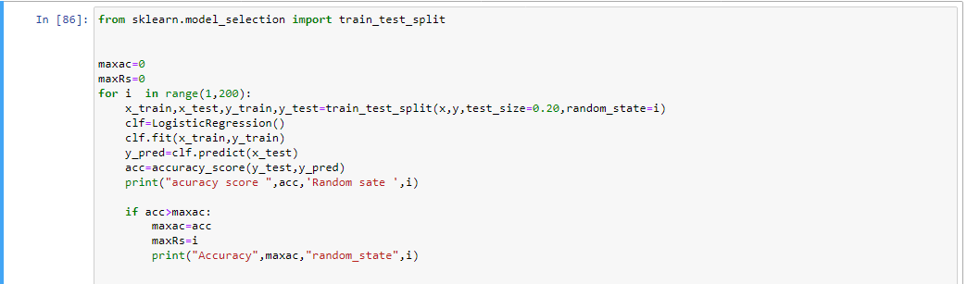

The maximum accuracy obtained with Logistic regression is 79.27 having random state is 53 with 20 % test size.

- Splitting dataset into Train and test

- Training of sklearn classifiers :
1 ] Logistic Regression
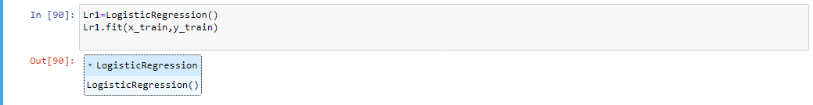
2] DecisionTreeClassifier
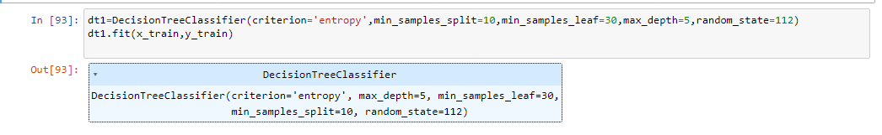
3] GradientBoostingClassifier
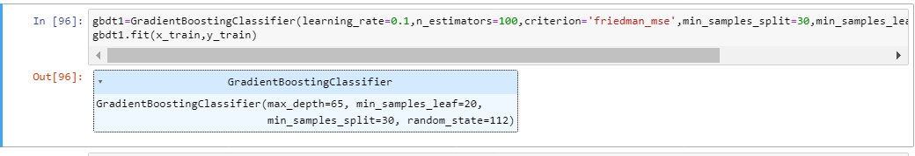
4] RandomForestClassifier
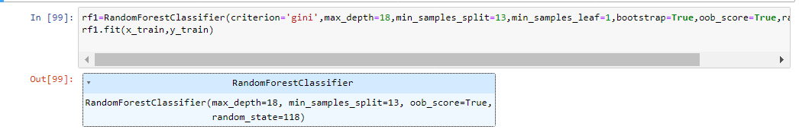
5] XGC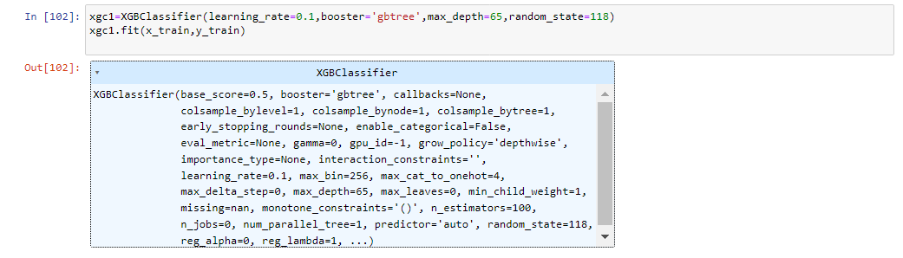
6] AdaBoostClassifier
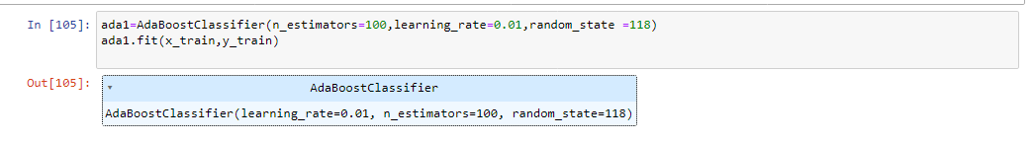
7] KNieghborsClassifier
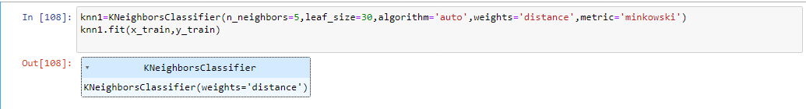
8] SVC
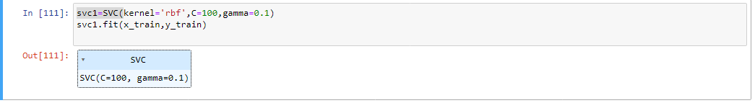
In above codes I have trained of various algorithms ,These all algorithms have fitted on our feature and labels Now I will define dataframe in which contains metrics like accuracy scores of train and test data , roc auc scores and validation score and also analyze for over fitting in each algorithm, which will be sophisticated .
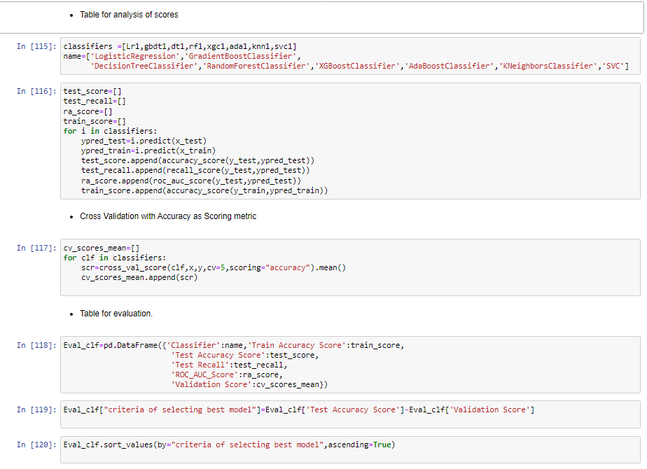
The Eval_clf is dataframe which has all information about metrics of algorithms which have trained for Churn prediction. It has columns Name of classifier and Metrics like Test Accuracy score, Train accuracy score, Test recall, ROC_AUC_Score, Validation_Score, and Criteria for selecting best model.
Cross validation: Cross-validation is a model assessment technique used to evaluate a machine learning algorithm’s performance in making predictions on new datasets that it has not been trained on. Cross-validation also helps with choosing the best performing model by calculating the error using the testing dataset, which has not been used to train. The testing dataset helps calculate the accuracy of the model and how it will generalize with future data. The model which least difference between Test score and Validation score is defined as Best performing model which is criteria of selecting best model. The parameters involved in cross_val_score are features, label, CV which number k folds and scoring which metrics to be used.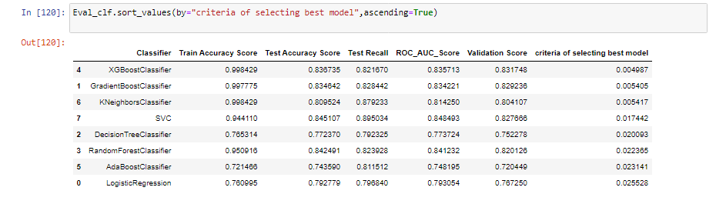
Observations: From The above dataframe it can be conclude that XGBClassifier, GradientBoostingClassifier and Kneighborsclassifier has performed without over fitting But XGBClassifier has least difference between Test score and validation score which is defined as best performing model. We will also analyze for Test and Train auc model
A] Train AUC for all classifier: There is method in sklearn metrics for plot_roc_curve() which will be return roc –auc of machine learning model. I have applied this method to get auc for each model and displaying it separately for test set and Train set.
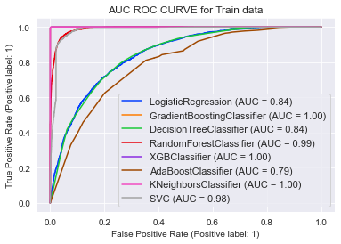
B] Test AUC for all classifier:
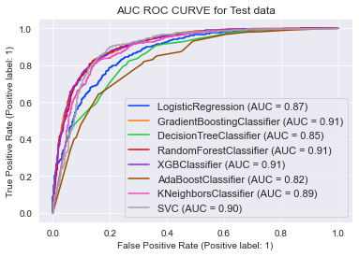
Observation: The performance of XGC is best with both train data and Test data. Auc for Train set is 1.0 and that of test set is 0.91.
Hyper parameter tuning with GridSearchCV: GridSearchCV is the process of performing hyper parameter tuning in order to determine the optimal values for a given model. This function helps to loop through predefined hyper parameters and fit your estimator (model) on your training set. So, in the end, we can select the best parameters from the listed hyper parameters. We will give list of hyper parameter which are near to parameter provide in given XGC model for iterate through the loop.
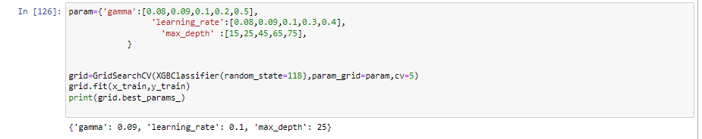
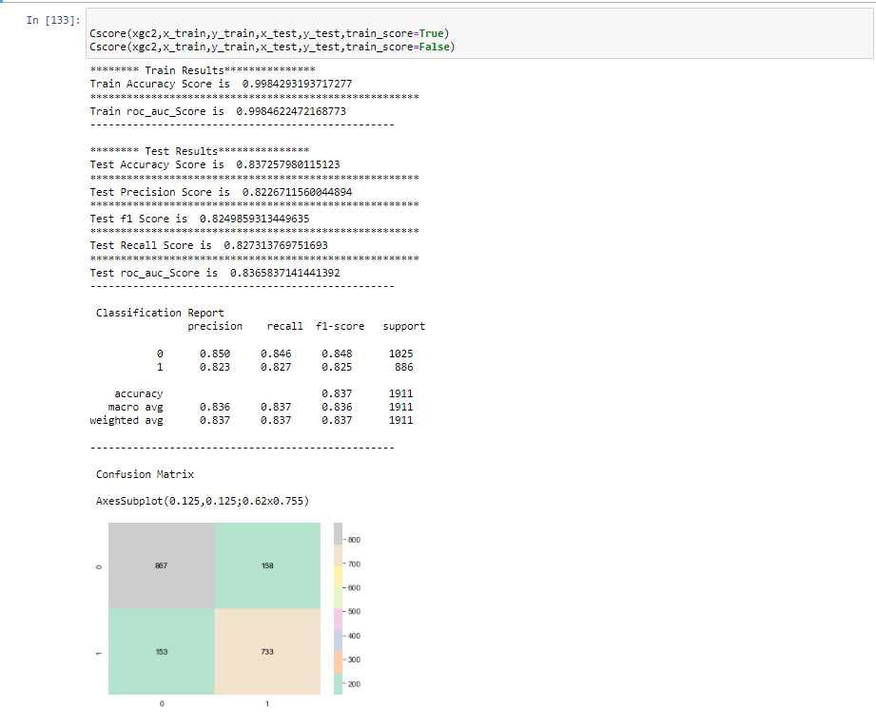
Note : I have defined Cscore fuction which takes test and train samples as input and returns algorithms metrics like accuracy score, recall, precision,f1 score, classification report and confusion matrix.
Observations:
XGBClassifier with hyperparametr gamma: 0.09, learning_rate: 0.1, max_depth: 25, random_state=118 is finalized as prediction model,. I have not got optimum score in Hyper parameter tuning due to system limitations , on feeding wide range of parameters we can definitely obtained optimum score .There is always try to improve performance , Never lose hope !
Evaluation metrics are as follows :
1] Test accuracy is 0.83725 i.e. 83.7 % approx.
2] Train Accuracy is 0.9984
3] roc auc score is 0.8365
4] Auc is graph is 0.91 for test and 1.0 for train data.

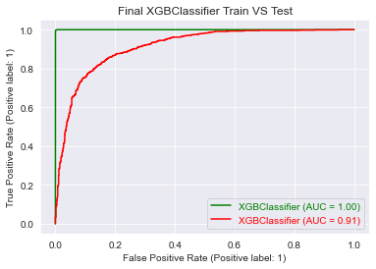

The given plot is roc_auc for final model which is 0.91 for test and 1.0 for Train model.

- Save a model :

- For saving model, I have imported joblib library and model is save in pickle file which will further used for model deployment.
- I have built machine learning model , on complete lifecycle of data science which initiate from importing libraries to saving a best performing model. There is always scope of improvement in machine learning and data science , on different analysis and techniques ,one can find better solutions.
- The Customer churn rate is crucial metric in business growth and life,. The Business with higher Churn can’t propagate and survive in this competitive era .In Telecommunication industry there is very fine barriers which can be easily attract customers with marketing strategies. The prediction of correct subset of customers can help to survive and growth of business . This prediction and Analysis can be key factor evaluate service quality .

Thanks, Stay safe Good Luck !

